

ADDIS ABABA INSTITUTE OF TECHNOLOGY

SCHOOL OF ELECTRICAL AND COMPUTER ENGINEERING

INFORMATION TECHNOLOGY AND SCIENTIFIC COMPUTING

DEPARTMENT OF SOFTWARE ENGINEERING

PROJECT II DOCUMENTATION ON

AMHARIC LANGUAGE GPS NAVIGATION FOR THE CITY OF ADDIS ABABA

BY:

BIRUK TAYE – ENR/3489/04

DURESA DEJENE – ENR/3726/04

HANNA MEKURIA – ENR/1801/04

SELAM MULUGETA – ENR/3805/04

ADVISOR: TIGABU DAGNE AKAL

JUNE 2016

Addis Ababa Institute of Technology

School of Electrical and Computer Engineering

Information Technology and Scientific Computing

Amharic Language GPS Navigation for the City of Addis Ababa

This Project documentation submitted in partial fulfillment of the requirements for the Degree of Bachelor of Science in Software Engineering.

Project Advised by:

Tigabu Dagne Akal

Name and signature of Members of the examining board:

Name Title Signature Date

1. __________________ Advisor _____________ _____________
2. __________________ Chairperson _____________ _____________
3. __________________ Examiner _____________ _____________
4. __________________ Examiner _____________ _____________
5. __________________ Examiner _____________ _____________

January 2016

Declaration of Originality

We declare that this project is our original work and has not been presented for a degree in any other university.

Name Signature Date

1. Biruk Taye __________________ __________________
2. Duresa Dejene __________________ __________________
3. Hanna Mekuria __________________ __________________
4. Selam Mulugeta __________________ __________________

This project II documentation has been submitted for examination with my approval as university advisor:

Tigabu Dagne Akal _________________________

June 2016

# ACKNOWLEDGEMENT

We, the development team, would like to express our very great appreciation to the center for Information Technology and Scientific Computing (ITSC) for enabling us to undertake the second phase of our final project, which is the implementation. We would like to offer our special thanks to our advisor, Mr. Tigabu Dagne, for his motivation and many advises and suggestions.

The developer team would also like to thank the undergraduate coordinators for looking into the proposed system and giving us the chance to develop it. We would also like to thank other instructors and staff members for enabling us to use the available resources of the center.

# ABSTRACT

Global Positioning System navigation tools have become a common item in the day-to-day lives of many societies in the world. They have become the backbone of navigation and service provider location for most individuals in the developed world. However, this trend is yet to be popular in Ethiopia and particularly in the city of Addis Ababa. As a major African city with offices of many international institutions and tourist attractions, the city does not have its own localized global positioning navigation system. Not only will these kinds of applications help the tourists coming to the city, it will also provide the residents in the wide metropolitan area of the city with much needed information of how to get around in the city and enjoy what it has to offer.

One of the issues faced by people in Addis Ababa is finding a good way of commuting from one place to another with ease and convenience as well as finding service providing facilities. This project is delivers an easy to use yet efficient and powerful application that runs on the android platform and is localized with the Amharic language.

The application incorporates navigation and service location and run them together to provide the user with multi-functionality. This will enable users to travel from one place to another, find a service provider at a certain location. In order to develop such systems for the city of Addis Ababa, some approaches had to be made by the developer team. The main issue is the availability of data of the city’s routes and precise locations of service providers that cannot be found on other online mapping services such as Google maps. The developer team approached the Ethiopian Mapping Agency for data and were provided with a hard copy of a detailed map that includes recent data on various locations and infrastructures such as the routes of the new light rail system.

It is evident that navigation and service provider location in the city is a daunting task not only for new comers but also to the veterans of the city and the developed system is intended to fix this issue.

Key words: GPS (Global Positioning System), Addis Ababa, Ethiopian Mapping Agency, Service Location, Service Rating, Navigation, Commuting

Table of Contents

ACKNOWLEDGEMENT iv

ABSTRACT v

List of Figures viii

List of Tables ix

ACRONYMS x

Chapter 1: INTRODUCTION and ORGANIZATION OF THE PROJECT 11

1.1 Introduction 11

1.2 Organization of the Project 11

Chapter 2: CHANGES MADE 13

Chapter 3: IMPLIMENTATION AND CONFIGURATION OF THE SYSTEM 14

3.1 Implementation 14

3.1 Configuration 15

Chapter 4: TEST RESULT 16

4.1 Introduction 16

4.2 Test Summary 16

4.2.1 Functional Test 16

4.3 Test Assessment 20

4.4 Test Results 20

Chapter 5: USER MANUAL 21

5.1 The Home Screen 21

5.2 The App Bar Menu 22

5.3 The Map Activity 23

5.3.1 Basic Map Activity 24

5.3.2 Particular Stations Display Activity 25

5.3.3 Search Service Provider Map Activity 25

5.3.4 Floating Action Menu Map Activity 26

5.4 House Destination Routing Map Activity 28

Chapter 6: CONCLUSION 29

# List of Figures

Figure 3‑1 Top Level Architecture of the System 14

Figure 5‑1 Application Home Screen 21

Figure 5‑2 The App Bar Menu 23

Figure 5‑3 Basic Map Activity 24

Figure 5‑4 Particular service selection activity 25

Figure 5‑6 Search Service Provider Activity 26

Figure 5‑7 Floating Action Menu Map activity 27

Figure 5‑8 House Destination Routing Map Activity 28

# List of Tables

Table 4‑1 Test Result - In-Car Navigation System 16

Table 4‑2 Test Result - Public Transportation Navigation Assistance 17

Table 4‑3 Test Result - Locate Service Providers 18

Table 4‑4 Test Result - Traffic Rule Assistance 19

Table 4‑5 Test Result – House Addressing 19

# ACRONYMS

MVC - Model View Controller

JSON – JavaScript Object Notation

SQL – Structured Query Language

API - Application Programming Interface

# Chapter 1: INTRODUCTION and ORGANIZATION OF THE PROJECT

## **1.1 Introduction**

The developer team of this GPS navigation system has provided a proposal documentation of the intended features and functionalities of the system on the last semester of this year. Furthermore, the team had developed a small prototype of one of the features of the system on the android platform. On this documentation the overall implementation, changes, configurations, user manual are included.

The developer team has implemented all the main and basic functionalities mentioned in the first phase of the project. The data collection was carried out from the Ethiopian Maps Agency, but due to some data insufficiency, the data was not used in its entirety. The team used data from Google maps in order to fill in some of the deficiency of data.

The priority of implementation followed by the team involves building the main functionalities of the system in the first weeks of implementation, and the user interface design and testing process on the last weeks of the development process.

Finally, the developer team has tried to approach the implementation of the project adhering as much as possible to the proposal submitted before this document. The overall functionalities have been met and successful tests have been conducted even though large scale user tests are not possible at this stage of the project.

## **1.2 Organization of the Project**

This documentation is structured into 6 chapters. The chapters include Introduction and Organization of the project, Changes made, Implementation and configuration, Test result, User manual and Conclusion.

The first chapter is the introduction and the organization of the project. It discusses the approaches made by the developer team in the implementation process and the overall structure of this documentation.

The next chapter, Chapter 2, discusses the changes made for the project. The developer team has made changes to some basic functionalities without altering the overall purpose of the project. These changes have been discussed on this chapter.

The third chapter discusses the Implementation and configuration of the project. This chapter discusses how the system has been made and the type of methodologies involved in the process. The configuration involves discussing the steps that should be taken to ensure the smooth running of the system.

The fourth chapter is about the test results. The team has tested the system in different scenarios and conditions. The results have been documented and discussed in this chapter.

The fifth chapter discusses the user manual. Step by step descriptions of the system together with screenshots are provided in this chapter.

The last chapter, Chapter 6, concludes the implementation documentation by highlighting the main issues in the document and the overall progress of the project through the two phases.

# Chapter 2: CHANGES MADE

The project implementation phase is completed but with some minor modifications. This phase of the project is guided by the documentation designed during the first phase of the project. The modifications do not bring a significant change on the functionalities of the product application. These are some of the changes made:

* The Yelp API was not used to implement the rating functionality because yelp doesn’t provide its service for our country.
* PostgreSQL DB was not used for the purpose of this project since it was not able to use the rich functionality of the Entity Framework because of some dependency issues. As a result of this the development team was forced to use the Microsoft SQL Server.
* The class diagram designed at the beginning of the project has been modified, mainly regarding the service provider and related classes. These changes came about because the service providers are not stored on the back end, instead all service providers and their detail information was taken from Google maps since their data is much richer than the data the team received from Ethiopian Mapping Agency. Even though the service provider class was taken from Google, all the methods on the service provider class are present and were developed by the team.
* Other modifications are due to easier user interfacing experience.
  + Users first get the shortest path displayed instead of all the alternatives, then the users can choose to get the second best path and so on.
  + The system will not alert when the users deviates from the suggested path.

# Chapter 3: IMPLIMENTATION AND CONFIGURATION OF THE SYSTEM

This section describes about how the system is implemented and its configurations so that it works as intended.

## **3.1 Implementation**

As the development team promised in the first phase of the project (Design Phase), a web-application to enter the data needed for the application is designed using ASP.NET MVC5. Using this web application, the administrator of the system could enter the data to the database which is designed using Microsoft SQL server. A web service, using Web API 2, is also designed so that the data entered through the web application could be accessed through the Android phone. The data will be serialized and passed as a JSON Object through a web browser and could be retrieved and desterilized through a java library called Retrofit. After the object is retrieved by the Android phone, combined with the Google Map API, the intended functionality of the system will be done.

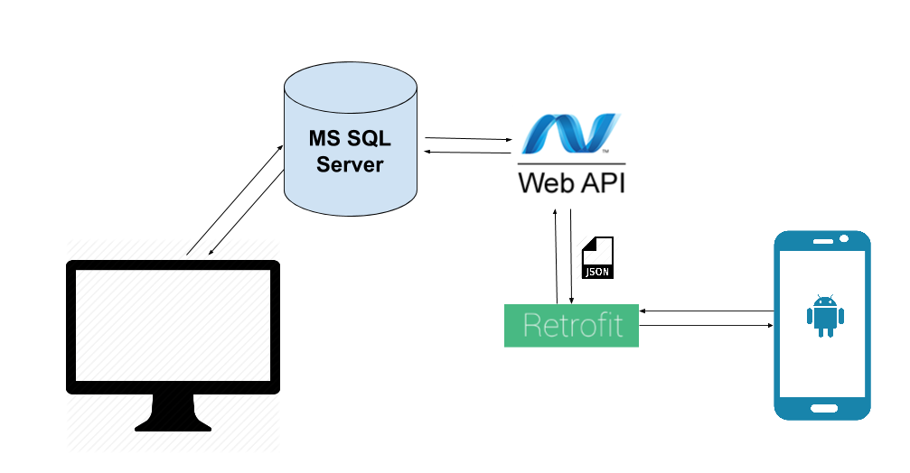

Figure 3‑1 Top Level Architecture of the System

The development team used the MVC architectural pattern for the implementation of the system (both the web-application and mobile application).

All the coding of the project for the web-application is done using Visual Studio 2015 Enterprise Edition version 14.0.23107 and .NET Framework 4.6.00079. And for android application, Android Studio 2.1 build number 143.2790544 and JRE 1.8 was used.

## **3.1 Configuration**

Because the web application and database is not deployed on a server, in order for the system to work some configuration should be made first.

1. Port no 40805 should be open for both inbound and outbound rules.
2. Run Visual Studio as an administrator.
3. Open the GPSNavigationSystem Project using Visual Studio Enterprise Edition 2015
4. Run the project.
5. Copy the files in the Database folder. Go to - C:\Users\[UserName] and paste the files. And replace them.
6. Go to Visual Studio and make sure both the GPSNavigationSystem.DataEntry and GPSNavigationSystem.WebService are running.
7. The username and password for the DataEntry are admin, 123abc123 respectively
8. Install the APK in the android phone.
9. Connect the desktop and phone to the same network
10. Open Android Studio and open Combo4
11. Go to java>google.com.combo4>API and open RetrofitInitializer
12. In the BASE_URL change the IP address to match the IP address of the desktop
13. Finally run the application on the Android phone

# Chapter 4: TEST RESULT

## **4.1 Introduction**

This Amharic language GPS navigation for the city of Addis Ababa Test Report provides a summary of the results of test performed as outlined within this document.

## **4.2 Test Summary**

**Project Name:** Amharic language GPS navigation for the city of Addis Ababa

**System Name:** Amharic language GPS navigation for the city of Addis Ababa

**Version Number:** 1.0

### **4.2.1 Functional Test**

**Test Owners:** Biruk Taye, Duresa Dejene, Hanna Mekuria & Selam Mulugeta

**Test Date:** Jun 4, 2016 – Jun 7, 2016

**Test Results:** Described in detail as following

Table 4‑1 Test Result - In-Car Navigation System

|  |  |  |  |  |
| --- | --- | --- | --- | --- |
| **Function Name** | **In-car Navigation** | | | |
| **Test Case ID** | **Test Case Description** | **Expected Result** | **Actual Result** | **Remarks** |
| 1 | Get Current location | Zoom in on the current location of the user. | Pass |  |
| 2. | Input Destination | Select destination from displayed markers. | Pass | The user selects destination by clicking on a marker. |
| 3. | Display Stations | Display all nearby stations. | Pass | The stations are categorized and are displayed according to the users’ choice. |
| 4. | Select Transport mode | User chooses by which transport mode to commute by. | Pass |  |
| 5. | Display Best Route | Draw the shortest route to the selected destination. | Pass | Multiple routes can be drawn to the same destination for the user to compare. |
| 6. | Display all route prices | All prices including the chosen transport mode’s price are displayed. | Pass | The user can uses this to choose the cheapest transport mode. |

Table 4‑2 Test Result - Public Transportation Navigation Assistance

|  |  |  |  |  |
| --- | --- | --- | --- | --- |
| **Function Name** | **Public Transportation Navigation** | | | |
| **Test Case ID** | **Test Case Description** | **Expected Result** | **Actual Result** | **Remarks** |
| 1 | Get Current location | Zoom in on the current location of the user. | Pass |  |
| 2. | Input Destination | Select destination from displayed markers. | Pass | The user selects destination by clicking on a marker. |
| 3. | Display Best Route | Draw the shortest route to the selected destination. | Pass | The alternative routes are drawn using sparse dotted directions. |
| 4. | Navigate turn-by-turn | Provide turning directions according to the path displayed. | Pass | The directions are given as Amharic voice notifications for drivers and using texts for other modes of transport. |

Table 4‑3 Test Result - Locate Service Providers

|  |  |  |  |  |
| --- | --- | --- | --- | --- |
| **Function Name** | **Service Provider Locator** | | | |
| **Test Case ID** | **Test Case Description** | **Expected Result** | **Actual Result** | **Remarks** |
| 1 | Get Current location | Zoom in on the current location of the user. | Pass |  |
| 2. | Search by service category | Select the service provider type to display selected nearby service providers | Pass | Service providers are displayed using category (service) dependent markers. |
| 3. | Search by name | All markers that match user text search input. | Pass | Users can get the nearest of the searched locations by clicking the nearest button. |
| 4. | Input Destination | Select destination from displayed markers. | Pass | If user clicks nearest button ,the destination will be set to the nearest service provider by default |
| 4. | Select Transport mode | User chooses by which transport mode to commute by. | Pass |  |
| 5. | Display Best Route | Draw the shortest route to the selected destination. | Pass | Multiple routes can be drawn to the same destination for the user to compare. |
| 6. | Display all route prices | All prices including the chosen transport mode’s price are displayed. | Pass | The user can uses this to choose the cheapest transport mode. |

Table 4‑4 Test Result - Traffic Rule Assistance

|  |  |  |  |  |
| --- | --- | --- | --- | --- |
| **Function Name** | **Traffic Rule Assistance** | | | |
| **Test Case ID** | **Test Case Description** | **Expected Result** | **Actual Result** | **Remarks** |
| 1 | Get Current location | Zoom in on the current location of the user. | Pass |  |
| 2. | Get user driving speed | The user speed is used to check if user exceeds speed limit. | Pass | Speed is calculated only if user claims to be a driver. |
| 3. | Get Road traffic signs | Retrieve all traffic rules assigned to a particular avenue. | Pass | Traffic sign location is saved as area (bound). |
| 4. | Traffic sign notification | Notify if user exceeds speed limit. | Pass | Current location and road traffic sign are cross checked to see if user is in a specific zone (road). |
| 5. | Display traffic signs | All traffic signs around the user’s location are displayed. | Pass | Only speed limit violations are notified to the driver. |

Table 4‑5 Test Result – House Addressing

|  |  |  |  |  |
| --- | --- | --- | --- | --- |
| **Function Name** | **House Addressing** | | | |
| **Test Case ID** | **Test Case Description** | **Expected Result** | **Actual Result** | **Remarks** |
| 1 | Get Current location | Zoom in on the current location of the user. | Pass |  |
| 2. | Search house location | All houses are searched and according to the users street and house number. | Pass |  |
| 3. | Display Search result | Searched house is displayed on the map. If house number doesn’t exist user is prompted to try again. | Pass | The searched house is used as destination after user chooses to draw route. |
| 4. | Input Destination | Select destination from displayed markers. | Pass | If user clicks nearest button ,the destination will be set to the nearest service provider by default |
| 5. | Select Transport mode | User chooses by which transport mode to commute by. | Pass |  |
| 6. | Display Best Route | Draw the shortest route to the selected destination. | Pass | Multiple routes can be drawn to the same destination for the user to compare. |

## **4.3 Test Assessment**

While testing the system, every single functional parts are tested in a qualified and complete ways that the development team are definitely sure that the system works well and can be used for the needed purpose it was created.

## **4.4 Test Results**

The functional test was very successful in general. Though there were difficulties with getting data such as House Addresses since they are not assigned properly for the whole specified area.

# Chapter 5: USER MANUAL

This user manual describes the way to use the application through the user interface. The user interface has been designed to be as easy and as user friendly as possible. Instead of cramming the interface with unnecessary texts, the developer team has decided to use mostly pictures as a means of communication. But should a user decide to see textual information, that option has been made available.

## **5.1 The Home Screen**

As the application is opened the user is able to see a simplified interface with easily recognized icons and is made aware of what type of service the app can provide them. All nearby locations can be accessed through this interface.

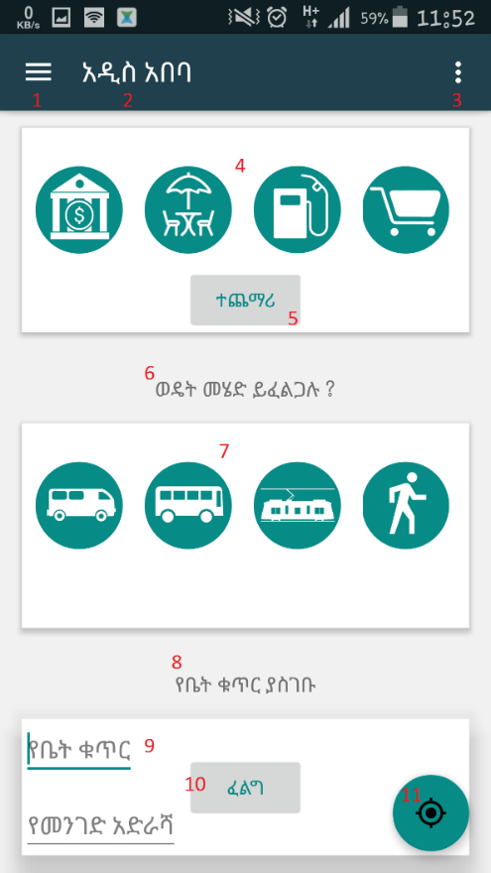

Figure 5‑1 Application Home Screen

1. Menu icon to open the app bar menu
2. App Name (Experimental and Prone to change)
3. Drop down menu
4. A frame layout that houses icons for service provider categories
   * Click on these icons to get the selected service provider locations.
5. A button to see more icons with their labels
   * Click more to expand and view more categories
6. Label that indicates the type of service
7. A frame layout with modes of transport type of icons
   * Click this to display all nearby stations of selected icon.
8. Label that indicates another type of service
9. Textbox to input data in
   * User inputs house number and street number to be pinpointed on the map
10. Button to search for a particular house
    * Displays the result house location

## **5.2 The App Bar Menu**

This feature allows the user to easily select the services provided by the application by tapping the menu button on the top left of the screen or by swiping right from the left side of the screen.

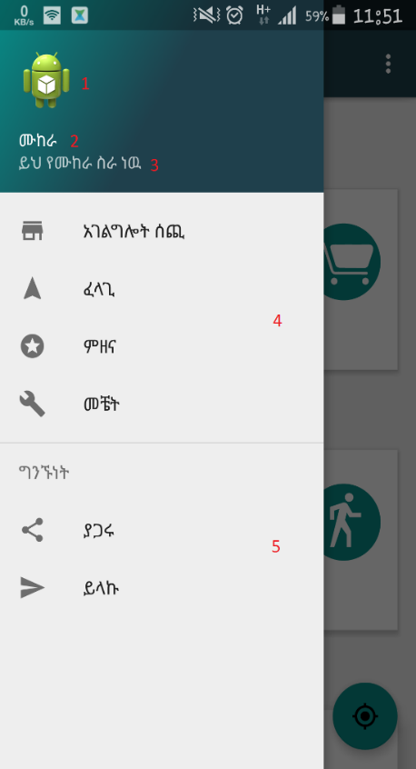

Figure 5‑2 The App Bar Menu

1. Application Icon (Experimental and Prone to change)
2. App Name (Experimental and Prone to change)
3. App Description (Experimental and Prone to change)
4. Menu items of services provided by the app
5. Social media sharing items for future use

## **5.3 The Map Activity**

The map activity is one of the main interfaces of the application. Since the user will spend most of their time on the map, the development team have incorporated Google maps since it is easy to use and well recognized.

### **5.3.1 Basic Map Activity**

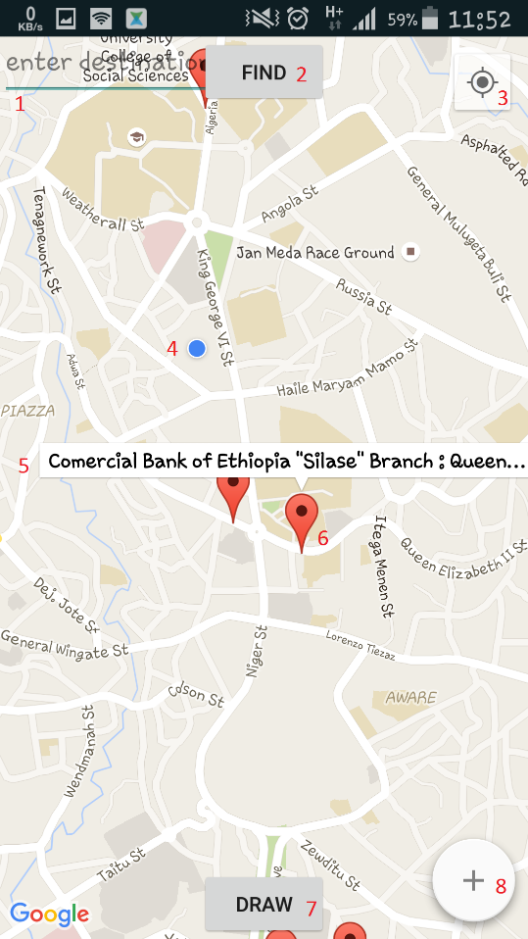

Figure 5‑3 Basic Map Activity

1. Enter the name of the desired service provider
2. Click Find button to display all markers that match the entered key word
3. Tap Button to get to current location
4. Current location marker (Blue marker)
5. Label of a particular service
6. Click marker to designate marker as destination
7. Button to draw route to selected destination
8. Click this floating action menu expand and display transport options

It is important to note that these icons will be replace in the final product to give more clarity to the user.

### **Particular Stations Display Activity**

This activity displays nearby stations for the specified station type.

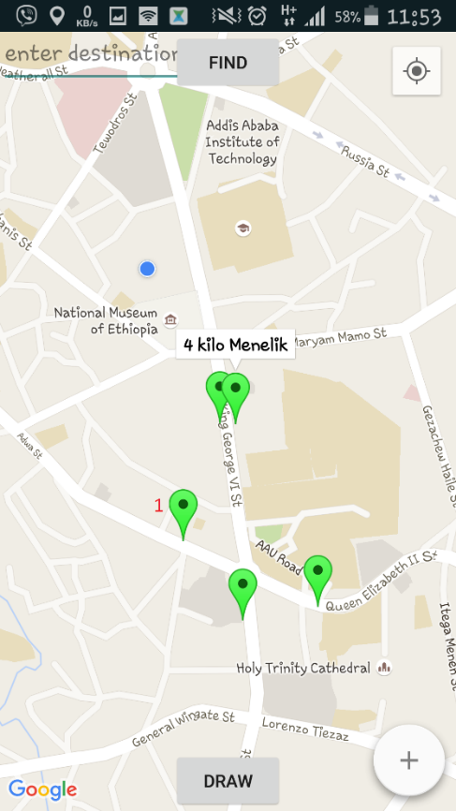

Figure 5‑4 Particular service selection activity

1. Click marker to display station name and also to specify it as the destination.

### **Search Service Provider Map Activity**

This form of map displays or activity is when a particular type of service provider is selected. For instance, in the figure below an ATM service is selected and the green markers indicate ATM

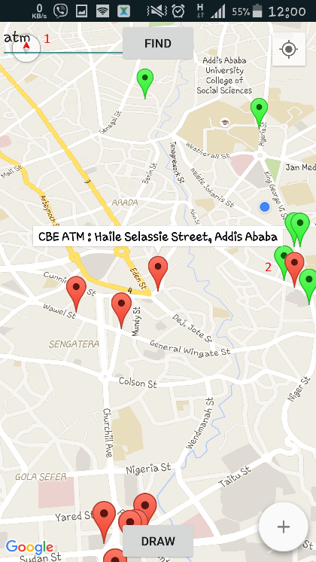

Figure 5‑5 Search Service Provider Activity

1. Search box for a service and click find button to get them displayed.
2. Red markers to indicate ATMS

### **5.3.4 Floating Action Menu Map Activity**

The developer team has included a simple floating action menu to provide easy access to the type of common modes of transportation they will want to use

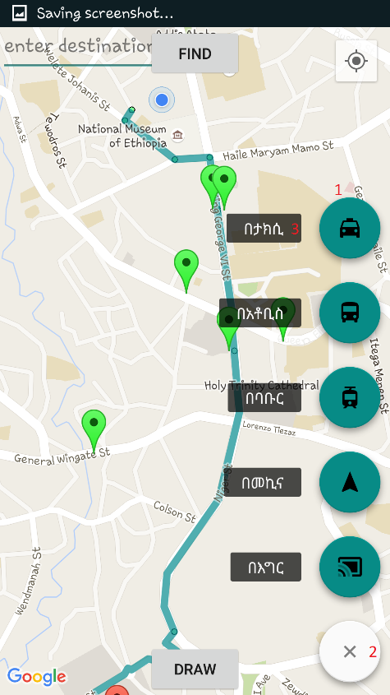

Figure 5‑6 Floating Action Menu Map activity

1. Click this button to draw route and get directions using taxi as mode of transport.
2. A floating action menu button to expand and close the menu items
3. A label of further clarify the mode of transportation

## **House Destination Routing Map Activity**

This interface shows when a route is calculated and drawn onto the map to a particular house destination.

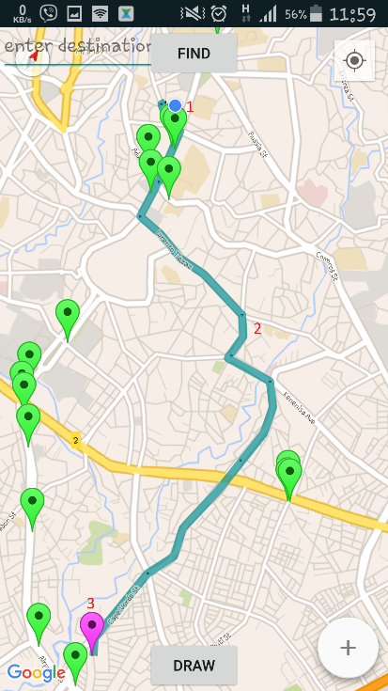

Figure 5‑7 House Destination Routing Map Activity

1. User location and routing start point
2. Route drawn onto map
3. Destination house marker (Experimental and Prone to change)

# Chapter 6: CONCLUSION

In general implementation has been conducted successfully with some scheduling inconsistencies compared to the first phase documentation. Although some functionality implementations took more time than intended, the project has been completed in time.

The project was first designed to help users’ day-to-day traveling experience easier. And the implementation also prioritized this fact during the realization of the project idea. The user interface is easy to navigate with multiple options to acquire the functionalities. The application has been run through multiple tests by random users and has been modified to suit the needs of the testers. The project has taken into consideration some important user concerns like data usage, battery usage and other related costs. To address these concerns the project team has taken measures accordingly. For example, users are not expected to keep their internet service ON during their travel, instead users can turn off data usage once the route is drawn and they will get every functionality.

The purpose of the application is to smoothen the travelling experience of the city’s people by providing support on any tasks related to navigation and service location. The project team believes this application successfully implements these objectives because the application provides a wide range of functionalities which are believed to essential in any navigation systems moreover the application contains two languages which is targeted for tourists and locals.